WORKING PAPER

Relationship of European Public Opinion to Defense Investments

As of 3/27/2015

Authors:  
 Gregory Sanders

Fellow, Defense-Industrial Initiatives Group

Center for Strategic and International Studies

Madison Riley

Researcher, Defense-Industrial Initiatives Group

Center for Strategic and International Studies

Samantha Cohen

Research Intern, Defense Industrial Initiatives Group

Center for Strategic and International Studies

Contributors

Meaghan Doherty and Abby Fanlo

For their work on the newest iteration of the CSIS European Defense Trends Report

Program Director

Defense Industrial Initiatives Group

Andrew Hunter

# Introduction

The Defense-Industrial Initiatives Group has undertaken this study on behalf of the Strategic Studies Institute at the U.S. Army War College. The study is intended to assess the relationship between public opinion and defense spending in Europe and, in turn, identify the regions or nations where defense spending and defense capabilities might grow. In an environment of diminishing capabilities as a result of declining defense budgets after the global economic crisis and the ongoing global threats, he United States Army can use our findings to better understand how public opinion may be a factor in their regional strategies and planning.

The team hypothesizes that public opinion has an effect on defense spending, and the direction of the effect depends on the polling question. We do not investigate the impact of elite public opinion when compared to general public opinion; instead, we are only looking to examine the general public opinion as reported by large international studies.

The two primary sources of polling data for our study are the Eurobarometer and Transatlantic Trends. However, for this working draft we have only analyzed data from the following two public opinion polling questions from Transatlantic Trends:

* Do you think your country should increase or decrease defense spending?
* How desirable is it that the United States exert strong leadership in world affairs?

Transatlantic Trends is conducted by the German Marshal Fund, and the Eurobarometer is conducted by the European Commission. Our other data are from a variety of other publicly available sources, to be described later. Working with the Transatlantic Trends data limited the number of countries in the study sample, but at the same time it increased the number of years covered while the data available from the Eurobarometer increases the number of countries and reduces the range of years.

The study team has run four different initial regressions on each of the polling question listed above: an ordinary least squares (OLS) regression, a fixed-effects and a random effects.

All results are listed in the appendix.

# Literature Review

Before analyzing the relationship between public opinion and defense spending, it is important to understand the political theories behind public opinion and public policy. A 1991 *World Politics* article by Thomas Risse-Kappen states that the “domestic structure” and the “coalition-building processes” of the country in question are key variables when determining public opinion and policy. [1] Risse-Kappen analyzes the relationship between public opinion and foreign policy in four democratic countries: the United States, France, Germany, and Japan. He finds that “The analysis of the interaction between public opinion and elite coalition-building processes in the four countries reveals that the policy outcomes differ according to variances in domestic structures and not in the international status of the states.”[2] In coming to this conclusion, Risse-Kappen identifies various political theories that are important to spot when studying public opinion and policy. These political theories enforce the idea that public opinion influences public policies.

The first political theory identified by Risse-Kappen defines the direction of influence between public opinion and foreign policy makers. He acknowledges that the pluralist theory of democracy suggests that a “bottom-up” approach occurs when leaders follow masses, while a “top-down” approach occurs when “popular consensus is a function of the elite consensus and elite cleavages trickle down to mass public opinion.”[3] According to international relations (IR) theory, a top-down approach is likely when the public policy issue at hand is less important to the public than other issues, the public knows little about the issue at hand, and the level of consistency of public opinion of a given country.[4] When analyzing the relationship between public opinion and policy in any given country, a robust analysis should take into account the nature of both the policy and the public opinion in question.

Risse-Kappen acknowledges the consequences of generalizing the public and their policy makers. For instance, he argues that the public falls into three different groups: “(1) mass public opinion, (2) the attentive public, which has a general interest in politics, and (3) issue publics, which are particularly attentive to specific questions.”[5] While his separation of the public is logical, the data for public opinion on policy issues that this paper uses does not make the same differentiation. Although each of these three different groups may influence public opinion differently, this paper defines the public’s opinion as a whole; in other words, it’s not differentiated.

In contrast, other scholarship on this topic argues that such a separation of the general public is not necessary when analyzing a public policy such as defense spending. Stuart N. Soroka and Christopher Wlezien, in their book titled *Degrees of Democracy* (2010), suggest that when determining whether the public’s preferences affects policies, their opinions need to indicate a general direction. Either the government is spending “too much” or “too little.” Soroka and Wlezien argue, “Citizens are able to use cues or heuristics to help them make decisions with only very basic information. … Politicians and parties also have a strong incentive to provide these cues.”[6] If this is true for defense spending policy, the separation of the public’s opinion into Risse-Kappen’s three groups is not necessary.

In regards to policy makers, Risse-Kappen enforces the importance of analyzing the country in question’s institutions. He uses a theory developed by Peter Katzenstein in 1976 suggests that countries institutions are either “strong” or “weak” depending on the “degree of centralization of state institutions and the ability of political systems to control society and to overcome domestic resistance.”[7] “Weak” states are more likely to have a strong relationship between public opinion and public policy, while “strong” states tend to act autonomously from the public.[8] Therefore, institutional power of a country should be defined before predicting the relationship between the public opinion and public policy of any given country.

Following this idea, Soroka and Wlezien enforce that there is a difference in policy representation between Parliamentary governments and Presidential governments, and further differences occur between conservative/republic dominated governments and progressive/democratic dominated governments. Soroka and Wlezien find that policy representation increases as a government changes from Parliamentary to Presidential because in parliamentary governments, “the executive is traditionally chosen from within the parliament and it serves only with the confidence of the latter.”[9] This supports the argument that public responsiveness in policy changes across countries, depending on their governments. While a variable measuring policy representation based on government type will be tested in this study, the panel data used will theoretically control for such differences between countries if government patterns remain the same.

Since the electoral majority of parties in European countries changes from election to election,[10] panel data will not adequately control for government in the relationship between public opinion and defense spending. Thus, this model will define a variable to measure the sort of government that would more likely pass higher defense budgets. In the paper *Party Competition and European Integration in the East and West* by Gary Marks, Liesbet Hooghe, Moira Nelson and Erica Edwards, the tendencies of political parties between Eastern and Western Europe are explored. Instead of just using the left-wing and right-wing categories to describe political parties, Marks et al. explore two alternative ways to describe parties: TAN and GAL. TAN stands for traditionalism/authority/nationalism and GAL stands for green/alternative/libertarian.[11] Marks et al. makes these distinctions because their research suggests that Eastern left-winged political parties have different tendencies than Western left-winged political parties on topics such as the environment, immigration and defense. This also applies to the different Eastern and Western right-winged parties. Thus, the study team will take this into account when describing the tendencies of electoral power in European governments and further the discussion in the data section of this paper.

Keeping Risse-Kappen’s introduction of the theories behind public opinion and policy in mind, Robert Y. Shapiro discusses the importance of connecting “majoritarian congruence, or agreement between majorities and government policies” versus “covariational congruence between opinion changes and policy changes.”[12] In 2011, Shapiro reviewed the research on public opinion and public policy in *The Public Opinion Quarterly*. In his review, he advocates for the importance of these relationships to be studied on the same scale. The relationship should be either between decisions of both public opinion and public policy or between changes of both public opinion and public policy.

Another important characteristic of the relationship between public opinion and public policy in democratic countries is electoral accountability. Shapiro argues that electoral accountability is “the most persuasive driving force,” in the relationship between the public and policy.[13] If electoral accountability does influence public policy, then it must be captured when modeling the relationship between public opinion and public policy.

Shapiro also enforces the theory that this relationship runs on a two-way street, saying, “Policies ultimately enacted may consequently be related to opinions that policymakers have helped shape through their rhetoric and behavior.”[14] When modeling the relationship between public opinion and policy, this possibility must be tested in order to create a robust estimate of how public opinion affects public policy. Shapiro’s suggestions are mirrored and further defined by Christopher Wlezien inthe *British Journal of Political Science* (January 1996), in which Wlezien invents the thermostat theory. He argues that public opinion acts similarly to a thermostat, “so that when policy differed from the favored policy temperature (which could itself change) the public would send a signal to adjust policy accordingly and, once sufficiently adjusted, the signal would stop.”[15] His model tries to mathematically capture this theory.

Wlezien’s thermostat model uses a variable defining the public’s relative preference to predict the thermostat theory. This relative preference is calculated by subtracting the policy level of defense spending (an increase or a decrease) from the public’s opinion on whether defense spending should increase or decrease. In Soroka and Wlezien’s 2010 book, *Degrees of Democracy* the authors further develop the thermostat model. They argued before that the public’s relative preference variable could not be directly defined because there was not data to observe the public’s opinion on defense spending.[16] In 2010, they model relative preference to be dependent on actual policy and a series of exogenous variables defining public preference. They then use defense spending and other exogenous variables to predict preferences and find that an increase in spending decreases the public’s preferences for defense spending. The dependent variable preferences, is calculated from the previous model explaining relative preference. They also compare this with the affect policy decisions (versus outlays) have on public opinion and find that outlays in defense policy impact the public’s opinion more than policy decisions such as appropriations.[17] This supports the research question investigated in this paper asking whether or not opinion affects defense spending. This theoretically could be irrelevant if the public was not affected by defense spending. Evidence from Soroka and Wlezien’s model, however, suggests that the public does respond to defense spending.

Wlezien (1996) also discusses the potential consequences of survey data. For instance, the relationship between public opinion and policy requires that the collection of public opinion data should be done at the same time each year. Otherwise, the public opinion data could contain a bias due to differences in how the public feels at different times each year.[18] The methods used by this paper’s data, taken from the German Marshall Fund’s Trans-Atlantic Trends annual public opinion assessment and the European Commission’s Eurobarometer, will be discussed later, in the Data section of this paper.

Gabriel A. Almond, in his 1956 *Public Opinion Quarterly* paper, is more focused on the relationship between public opinion and national security policy, and he discusses the public opinion’s effect on national security rather than public policy as a whole. Almond argues that public opinion follows government initiatives more than any other policy sphere, i.e. public opinion depends more on security policy than defense spending, which directly pertains with is paper’s initial research question.[19] Almond suggests that the public looks to the media as the means of communication from the government in order to form their opinions on security issues. He further argues that national security issues are by nature highly technical, and often sensitive information can carry high risks to the public.[20] This connects to Risse-Kappen’s previously discussed “top-down” approach: to the public, national security issues, such as defense, can theoretically be less important or not as well understood than other issues. This causes two implications for modeling this relationship. The first is capturing the “thermostat effect” of a two-way equation, and the second is capturing the bias that might result from the nature of the media in any given country. These implications will be discussed in the Model section of this paper.

While the direct relationship in this model is between public opinion and defense spending, there are many factors that influence defense budget policy. In order for the model to predict a robust estimate, these other factors must also be taken into consideration. In 2010, Sarah Kreps writes in *Foreign Policy Analysis* about the public opinion’s clout when it comes to defense decisions in countries that belong to an alliance*.* In a case study on countries contributing to operations in Afghanistan, Kreps finds that the public has little clout in the policies made during that time.

When looking at the relationship between public opinion and government leaders during the war in Afghanistan, Kreps finds that “when there are low levels of public support, which generally exists in non-American member states of the coalition, leaders disregard hostile public opinion by not reducing nor withdrawing their troops from Afghanistan,” thus determining whether there is variation in how policy responds to public opinion for countries within an allied force such as NATO.[21] Kreps notes that countries with low public support increase their troop numbers while simultaneously lowering the troops’ restrictions.[22] She further argues that this occurs because when countries belong to NATO, governments are “sensitive to the costs of international deflection and converge around a commitment to international cooperation, which reduces the electoral and foreign policy effects of public opinion.”[23] This makes it clear that whether or not a country is in NATO affects their public policy on defense engagements. The study team plans on using a variable to capture this effect, which will be further detailed in the Data and Model sections.

Richard C. Eichenberg’s paper from *The Journal of Conflict Resolution* (August 2003) models public opinion and defense budgets in five democratic countries from 1960 to 1998. His model includes control variables that are factors in determining defense spending. Eichenberg argues that public opinion responds to the ratio of defense spending to social spending.[24] For instance, if the GDP of a country is lower than the defense budget, the public will likely vote to reduce defense spending. This also mimics the thermostat theory; public opinion will adjust according to levels of spending relative to the economy and policy will change in response, causing the public to reassess their demands.

Eichenberg also includes NATO as an alliance variable. He argues that because countries that belong to alliances such as NATO are under pressure to spend more on defense and not free-ride, public opinion will be more “sensitive” to the status of the defense budget.[25] Thus, model will test an alliance variable that will be further discussed in the Data and Models section of this paper. Eichenberg also assumed that countries belonging to NATO would compare their defense budgets to that of the United States. He used a variable measuring “the gap between the real percentage growth of U.S. defense spending and the real percentage growth of each state’s defense spending.”[26] This exploration of NATO’s involvement in affecting defense budgets will be mirrored in this paper’s model by using a variable to capture countries’ involvement in NATO.

Another control variable that Eichenberg uses is different types of conflict involvement. The majority of his study spans the Cold War; thus, a variable capturing Soviet involvement was used. Similarly, Soroka and Wlezien use two conflict variables: one that captures Soviet involvement and another that captures the events that occurred on September 9, 2011.[27] This merits the investigation of such influences in this study. Eichenberg also uses a variable that captured international conflict.[28] Furthermore, internal conflicts such as civil wars or economic recessions are estimated to have an effect on defense spending.[29] Thus, this paper will also explore variables similar to the internal and external conflicts listed, because they tend to be associated with an increase in defense spending.

Thomas Hartley and Bruce Russett, in *The American Political Science Review* (1992), investigate whether public opinion for defense spending results in the desired outcome of defense spending. Their study uses regression models while controlling for factors such as Soviet involvement to predict the relationship. They also explore the possibility of a multi-directional relationship and test for it with a Vector Autoregressive model. This paper will also explore this model, which can be found in the Models section. Hartley and Russet end their article by discussing how media may be a significant part of the relationship between public opinion and defense spending policy because it’s a common believe that the media affects public opinion.[30] They do note, however, that a consistent variable regarding the media has yet to be defined.

# Data

The data used for this analysis is panel data, gleaned from seven different datasets and forms an unbalanced panel.. The foundational data is from the German Marshall Fund’s Transatlantic Trends annual public opinion assessment in Europe and the United States. The first set of public opinion data is in response to the question, “Do you feel that your country should increase, decrease, or keep defense spending the same?” This data set includes responses from 14 countries over the years 2002, 2003, 2004, 2008, 2011, 2012, and 2013. The countries in that dataset are Bulgaria, France, Germany, Italy, The Netherlands, Poland, Portugal, Romania, Russia, Sweden, Slovakia, Spain, Turkey, and the United Kingdom. The second public opinion data set details responses to the question, “How desirable is it that the United States exert strong leadership in world affairs?” There are responses from 12 countries: France, Germany, Greece, Italy, The Netherlands, Poland, Portugal, Russia, Sweden, Spain, Turkey, and the United Kingdom. The panels are unbalanced and, depending on the model, the total number of observations ranges from 54 to 56 for the increase or decrease spending question and 92 to 93 for the U.S. leadership question. The study team added defense spending and the other control variables described below to this data.

We drew the defense spending data from a previously conducted CSIS study on trends in European defense spending.[31]We then collected data from other open source datasets to compile the remaining control variables.

* Threat Ratio – The data for this control variable comes from two sources: the Stockholm International Peace Research Institute’s (SIPRI) annual defense expenditures dataset and the World Bank. We downloaded the newest data from SIPRI and summed the defense spending of all contiguous neighbors for each study country. Then we divided each total by the GDP of the corresponding study country. All values were computed using U.S. dollars. The data for defense spending was in constant 2011 dollars and the data for GDP was in constant 2005 dollars. We used SIPRI data because the data from our own internal study did not cover all of the contiguous neighbor countries needed to compute the variable.
* Variable name? - The data for both international and domestic terror attacks came from the Global Terrorism Database, which is compiled and maintained by the University of Maryland. The database contains data on over 125,000 terrorist incidents, with over a hundred observations for each attack. We counted the number of attacks per year that fell into the category of logistically domestic or international. This means the aggressor must have crossed an international border to commit the act. Any incidents in which this information was unknown were excluded from the study.
* Conflict Variable - Data on International Conflicts and Civil Wars came from the Correlates of War (COW) database. For civil wars, we created a dummy variable of whether a country had experienced a civil war within the preceding 20 years, based on COW’s intra-state wars data. For the international conflict variable, we recorded any instance in which a country was engaged in what COW defines as a “militarized interstate dispute.” This includes international disputes ranging from the mobilization of troops intended to threaten or persuade another country to armed conflict. Unlike for civil war, we recorded international conflicts only for the years in which they occurred, not for whether there had been one during a previous set time.
  + An important note regarding this data is that international peacekeeping operations and United Nations military interventions do not count.
* Population and GDP per capita data was drawn from the World Bank. GDP per capita data is in constant 2005 USD.
* Data on Democracy was drawn from the Polity IV Project and is defined as a value from one to ten, based on a yearly scoring conducted by Polity IV.
* Data for the NATO membership variable was computed using information from NATO’s website. The variable is binary where one indicates NATO membership for that corresponding year.

# Our Methodology

After going through the literature, we decided on the following model for our regressions:

$${Ln\left(Defense Spending\right)}_{t+1}= a_{0}+ β_{1} Public Opinion Spread+ β_{2} Threat Ratio+ β_{3} International Terror Attack+ β_{4} Domestic Terror Attack+ β_{5} Civil War+ β_{6} International Conflict+ β_{7}ln\left(Population\right)+ β_{8}\ln\left(GDP per Capita\right)+ β_{9} Democracy Score$$

Within this model, we lag every variable one year behind defense spending. We do this because we know that budget proceedings will happen one to two years before defense expenditures occur. We intend to also run regressions on all of the variables lagged two years behind defense spending, but we have not yet reached that step in our work. We also use the log of Defense Spending, Population, and GDPpC in conjunction with common practices surrounding large numbers.

We began our analysis with a step regression for each of the public opinion questions, in order to examine the effects each control has on the descriptive statistics of the OLS model. By examining these effects, it can be determined whether or not each control variable has a meaningful impact on the estimates of the relationship. The tables for the public opinion step regressions are listed in the appendix as Figure 1 and 3.

After running the step model all the way up to our full OLS regression model, we then moved on to using a fixed-effects model. Because of our results, we are aware of auto-correlation and correlation between our regressors; however, we have not yet begun the process of statistically dealing with those issues.

The fixed-effects models control for bias in the estimates that potentially occur when using panel data. Because panel data observes countries over time, there are likely unmeasurable variables that could influence defense spending. These unmeasurable variables could be either related to the nature of each individual country or related to factors that change over time. For example, the culture of a country could influence public opinion or defense spending. Furthermore, world events that occur across all countries but vary throughout time could influence public opinion or defense spending. Thus, using a model that controls for these possibilities is the most accurate way to estimate the relationship. Fixed effect regressions control for this potential bias through an additional variable that is comprised of the intercepts for each observation (each country at each year). This allows the model to estimate the impact of public opinion on defense spending while unobservable characteristics of each country, which may also influence defense spending, are controlled for. Thus, we executed two additional models for whether to increase or decrease defense spending and whether U.S. global leadership. One controls for country fixed effects, and the other controls for time fixed effects.

## Assumptions

This analysis makes certain assumptions about the European regional security environment. The first is that budget uncertainty as a result of the global financial crisis will continue to place pressure on defense budgets, but the European Union and the Euro-zone will not break up. The next is that publicly reported European budget and acquisition figures are reliable. Finally, defense spending figures, even when credible and not undercut by corruption, are not an exact measure of capability. However, these figures, when examined in detail and with multiple approaches, are a useful proxy for whether defense capabilities are adequately resourced.

This analysis also makes certain assumptions about the European polling. The first is that in liberal democracies, public opinion on defense in foreign policy matters is one factor among many that influences defense spending levels and priorities, as well as the extent of cooperation with neighboring countries. The next is that moves in public opinion may or may not reflect moves in elite opinion, but in either case, public opinion changes faster than budget and acquisition policy and therefore is a leading indicator. Another is that public opinion can be meaningfully measured on an annual basis. Finally, we assume that Eurobarometer and Transatlantic Trends reports are effective measures of national level public opinion.

This analysis also operates under a number of assumptions about the United States security environment. One is that budget uncertainty as a result of sequestration and the Budget Control Act will continue, with resulting requirements to reduce end strength and carefully prioritize acquisition and engagement activities. Next, emergent and continuing crises around the world, similar to ISIS in Iraq, Syria’s ongoing civil war, possible terrorist activity in parts of Africa, and non-traditional security requirements such as the present Ebola outbreak in West Africa, will be persistent and will require some level of U.S. military response and, as a result, increased European capability. Finally, NATO allies and traditional partners will continue to be supportive of the United States’ positions and efforts within Europe and in some cases abroad, but their own resource constraints will limit the degree to which they are able to participate with the U.S., in either response actions or engagement activities.

# Initial Observations

Initial analysis has found that public opinion does correlate in the expected direction for the two initial questions under regression models. Given clear United States government support for higher European defense spending, it is natural that support for U.S. leadership would be associated with higher defense spending levels. The second polling question, concerning whether defense budgets increase or decrease, also aligns as expected with higher defense spending. This was true for some of the fixed-effect models, although for the model2, in which country-effects are held constant, the sign is reversed for U.S. support and not significant for support of increasing defense spend.

However, at this stage there are multiple significant caveats. First, some of the variables are correlated with one another in a manner that could confound the model. Addressing these relationships will be an important . Second, the study team will want to further increase its understanding of how some of the variables interact with defense spending, particularly those relating to the threat ratio, terrorism, and other conflicts. Third, the fixed-effects models did not return a consistent result regarding the public opinion variable. A future step will be to create a model that holds both country and time constant.

The final challenge is that the coefficients for both polling variables are notably small. This is consistent with the literature that does not treat public opinion as a major determinant of defense spending. However, should the relationship stay robust while the model is refined, a weak connection still has the potential to be illuminating. The most interesting polling questions may not be those with direct implications for military spending, but instead those relating to opinion of the European Union, fears of terrorism, and other potentially relevant policy topics.

As the

# Appendix

Glossary

Dspend (Defense Spending), ThrtR (Threat Ratio), DomAt (Domestic Terrorist Attacks), IntAt (International Terrorist attacks) CivWr (Civil War in last 20 years), IntWr (International International Conflict), Pop (Population), GDPpC (GPD per capita), Dem (Democracy), NATO (NATO membership) PubOp (Public Opinion variable)

Table 1 - Summary of Variables for US Leadership Regression

|  |  |  |  |  |  |  |  |
| --- | --- | --- | --- | --- | --- | --- | --- |
| **US Lead Sum** | Min | 1st Qu. | Median | Mean | 3rd Qu. | Max | Nas |
| Dspend | 3.09E+09 | 1.02E+10 | 1.83E+10 | 2.91E+10 | 5.00E+10 | 7.93E+10 | 23 |
| ln(Dspend) | 21.85 | 23.04 | 23.63 | 23.71 | 24.64 | 25.10 | 23 |
| ThrtR | 0.000 | 0.039 | 0.055 | 0.081 | 0.076 | 0.351 | 15 |
| IntAt | 0.00 | 0.00 | 0.00 | 0.28 | 0.00 | 4.00 | 13 |
| DomAt | 0.00 | 0.00 | 0.00 | 4.79 | 2.00 | 141.00 | 13 |
| CivWr | 0.00 | 0.00 | 0.00 | 0.09 | 0.00 | 1.00 | 2 |
| IntWr | 0.0 | 0.00 | 0.00 | 0.06 | 0.00 | 1.00 | 2 |
| Pop | 9.45E+06 | 3.81E+07 | 5.83E+07 | 4.87E+07 | 6.46E+07 | 8.25E+07 | 13 |
| GDPpC | 6,047 | 20,470 | 34,340 | 31,780 | 42,110 | 59,590 | 13 |
| ln(pop) | 16.06 | 17.46 | 17.88 | 17.51 | 17.98 | 18.23 | 13 |
| ln(GDPpC) | 8.71 | 9.93 | 10.44 | 10.22 | 10.65 | 11.00 | 13 |
| Dem | 8.00 | 10.00 | 10.00 | 9.73 | 10.00 | 10.00 | 13 |
| NATO | 1.00 | 1.00 | 1.00 | 1.00 | 1.00 | 1.00 | 6 |
| PubOp | -71.00 | -23.50 | 2.00 | -2.82 | 20.00 | 53.00 | 0 |

Table 2 - Summary of Variables for Increase or Decrease Defense Spending

|  |  |  |  |  |  |  |  |
| --- | --- | --- | --- | --- | --- | --- | --- |
| **IncDec Sum** | Min | 1st Qu. | Median | Mean | 3rd Qu. | Max | NA's |
| Dspend | 7.19E+08 | 5.17E+09 | 1.40E+10 | 2.37E+10 | 4.21E+10 | 6.77E+10 | 13 |
| ln(Dspend) | 20.39 | 22.37 | 23.36 | 23.23 | 24.46 | 24.94 | 13 |
| ThrtR | 0.00 | 0.04 | 0.06 | 0.13 | 0.08 | 0.89 | 3 |
| IntAt | 0.00 | 0.00 | 0.00 | 0.31 | 0.00 | 4.00 | 6 |
| DomAt | 0.00 | 0.00 | 0.00 | 4.96 | 1.25 | 141.00 | 6 |
| CivWr | 0.00 | 0.00 | 0.00 | 0.08 | 0.00 | 1.00 | 1 |
| IntWr | 0.00 | 0.00 | 0.00 | 0.04 | 0.00 | 1.00 | 1 |
| Pop | 5.37E+06 | 1.62E+07 | 4.63E+07 | 4.32E+07 | 6.36E+07 | 1.43E+08 | 0 |
| GDPpC | 6,047.00 | 13,650.00 | 30,150.00 | 28,630.00 | 40,510.00 | 59,590.00 | 0 |
| ln(pop) | 15.50 | 16.60 | 17.65 | 17.26 | 17.97 | 18.78 | 0 |
| ln(GDPpC) | 8.71 | 9.52 | 10.31 | 10.08 | 10.61 | 11.00 | 0 |
| Dem | 5.00 | 9.00 | 10.00 | 9.64 | 10.00 | 10.00 | 0 |
| NATO | 1.00 | 1.00 | 1.00 | 1.00 | 1.00 | 1.00 | 4 |
| PubOp | -51.00 | -30.00 | -11.50 | -11.68 | 3.00 | 35.00 | 0 |

Figure 1 - US Leadership Step Regression

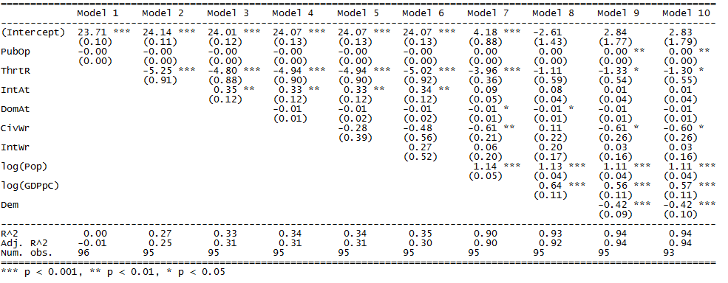

Figure 2 - Regression of US Leadership Public Opinion

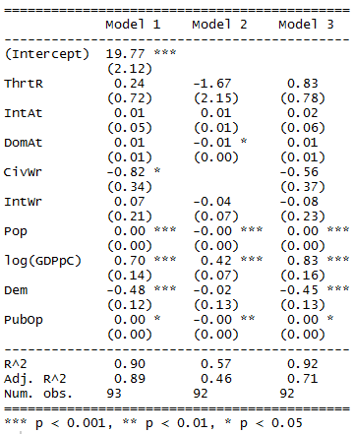

Figure 3 - Increase Decrease Defense Spending Step Regression

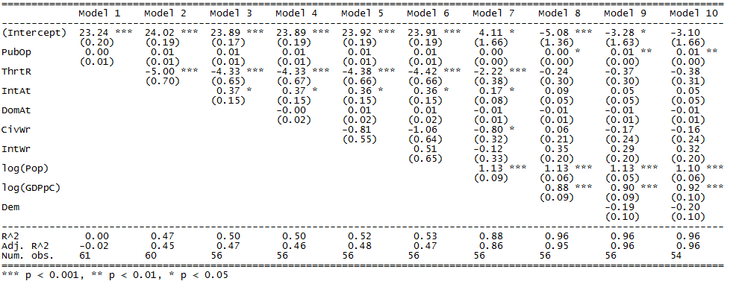

Figure 4 - Increase or Decrease Defense Spending Regression Results

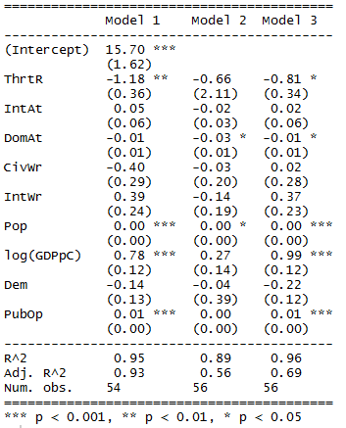

1. (Risse-Kappen 1991)
2. (Risse-Kappen 1991)
3. (Risse-Kappen 1991)
4. See note 3 above.
5. See note 3 above.
6. (Soroka and Wlezien 2010)
7. See note 3 above.
8. See note 3 above.
9. See note 6 above.
10. <http://electionresources.org>
11. (Marks, 2006)
12. (Shapiro 2011)
13. See note 10 above.
14. See note 10 above.
15. (Wlezien 1996)
16. Soroka and Wlezien (2010)
17. See note 14 above.
18. See note 13 above.
19. See note 13 above.
20. (Almond 1956)
21. (Kreps 2010)
22. See note 17 above.
23. See note 17 above.
24. (Eichenberg and Stoll 2003)
25. See note 20 above.
26. See note 20 above.
27. See note 6 above.
28. See note 20 above.
29. See note 20 above.
30. (Hartley and Russett 1992)
31. The link to the final product, distributed in a briefing update format, can be found at the following link. <http://csis.org/files/publication/150105_Berteau_EuropeanDefenseTrends2014_BriefingUpdate_Web.pdf>. Some of the data from the study is available on the CSIS DIIG Github account.